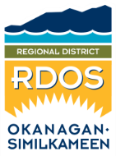 | Feedback Form  Regional District of Okanagan-Similkameen  101 Martin Street, Penticton, BC, V2A 5J9  Phone: 250-492-0237 Email: planning@rdos.bc.ca

TO: Regional District of Okanagan-Similkameen FILE NO.: D2026.004-ZONE

FROM: Name: _____________________________________________________
(please print)
Street address: ______________________________________________________
Date: ______________________________________________________

RE: Okanagan Falls Official Community Plan (OCP) Bylaw No. 3148; and
Okanagan Falls Zoning Bylaw No. 3149.

My comments/concerns are:
I do support the proposed Okanagan Falls OCP & Zoning Bylaws.
I do not support the proposed Okanagan Falls OCP & Zoning Bylaws.

Please provide any comments you wish the Board to consider:

Feedback Forms must be submitted to the RDOS office before noon on July 6, 2026.
All representations, including names, will be made public if and when they are included in the Board Agenda.

