
Development
Variance Permit

FILE NO.: I2025.034-DVP

Owner: |  |  | Agent:

GENERAL CONDITIONS
- This Development Variance Permit is issued subject to compliance with all of the bylaws of the Regional District of Okanagan-Similkameen applicable thereto, except as specifically varied or supplemented by this Permit.
- The land described shall be developed strictly in accordance with the terms and conditions and provisions of this Permit, and any plans and specifications attached to this Permit that shall form a part thereof.
- Where there is a conflict between the text of the permit and permit drawings or figures, the drawings or figures shall govern the matter.
- This Development Variance Permit is not a Building Permit.

APPLICABILITY
- This Development Variance Permit is substantially in accordance with Schedules ‘A’, ‘B’, ‘C’, ‘D’, ‘E’ and ‘F’, and applies to and only to those lands within the Regional District described below, and any and all buildings, structures and other development thereon:
Legal Description: | Lot A, Plan KAP42167, District Lot 105S, SDYD
Civic Address: | 257 Oak Avenue, Kaleden
Parcel Identifier (PID): | 015-257-690 Folio: I-01460.010
CONDITIONS OF DEVELOPMENT
- The land specified in Section 5 may be developed in accordance with the following variances to the Okanagan Valley Zoning Bylaw No. 2800, 2022, in the Regional District of Okanagan-Similkameen:
- the maximum front side parcel line height for a retaining wall, as prescribed in Section 6.13.5, is varied:
  - from: 2.0 metres
to: 2.8 metres to the outermost projection as shown on Schedule ‘C’
- the maximum rear side parcel line height for a retaining wall, as prescribed in Section 6.13.4, is varied:
  - from: 2.0 metres
to: 3.4 metres to the outermost projection as shown on Schedule ‘C’

COVENANT REQUIREMENTS
- Not Applicable

SECURITY REQUIREMENTS
- Not applicable

EXPIRY OF PERMIT
- The development shall be carried out according to the following schedule:
- In accordance with Section 504 of the Local Government Act and subject to the terms of the permit, if the holder of this permit does not substantially start any construction with respect to which the permit was issued within two (2) years after the date it was issued, the permit lapses.
- Lapsed permits cannot be renewed; however, an application for a new development permit can be submitted.

Authorising resolution passed by the Regional Board on ________________, 2026.

___________________________________
J. Zaffino, Chief Administrative Officer

Regional District of Okanagan-Similkameen
101 Martin St, Penticton, BC, V2A-5J9
Tel: 250-492-0237 Email: planning@rdos.bc.ca

Development Variance Permit File No. I2025.034-DVP
Schedule ‘A’
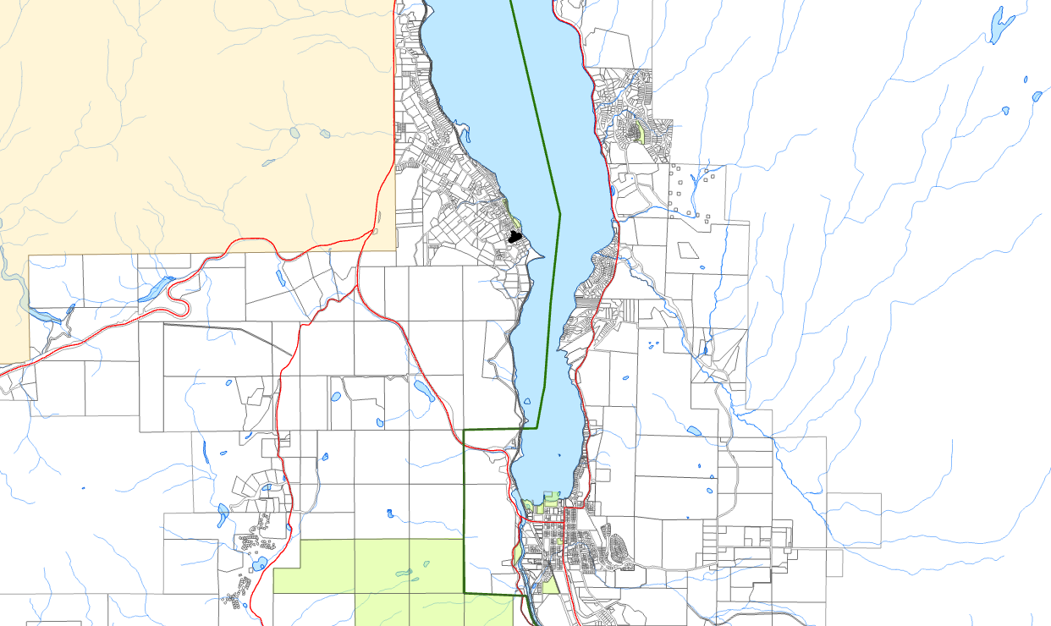
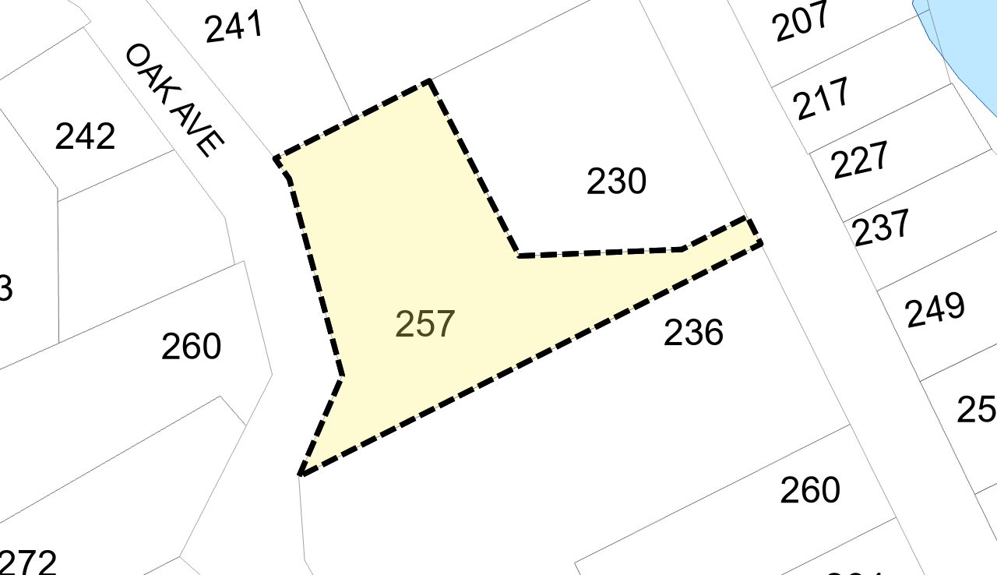
OAK AVENUE
SKAHA LAKE
OK FALLS
KALEDEN
Subject
Parcel
Regional District of Okanagan-Similkameen
101 Martin St, Penticton, BC, V2A-5J9
Tel: 250-492-0237 Email: planning@rdos.bc.ca

Development Variance Permit File No. I2025.034-DVP
Schedule ‘B’
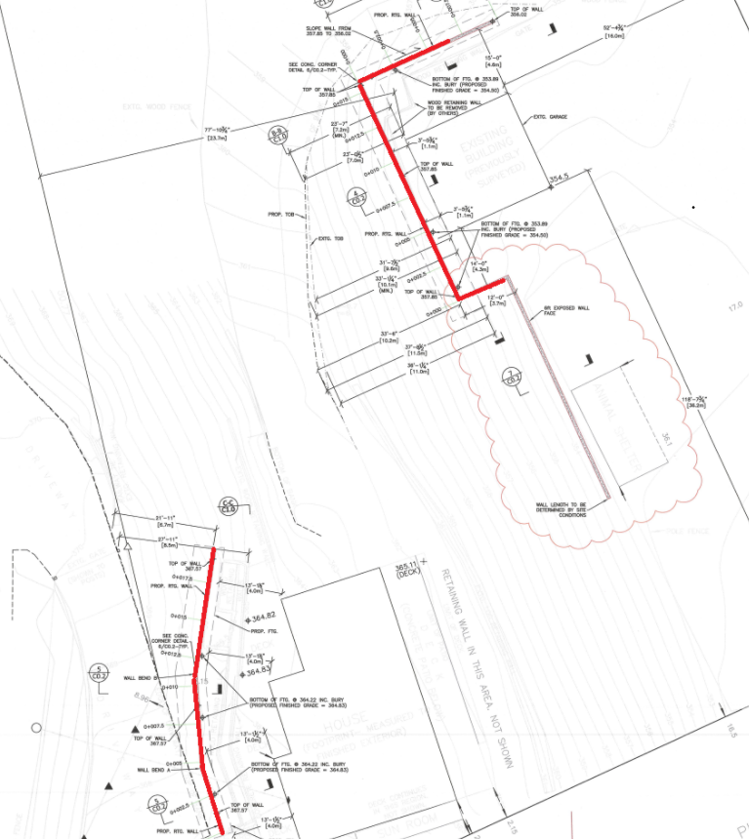
2.8 metres
3.4 metres

Regional District of Okanagan-Similkameen
101 Martin St, Penticton, BC, V2A-5J9
Telephone: 250-492-0237 Email: info@rdos.bc.ca

Development Variance Permit File No. I2025.034-DVP
Schedule ‘C’
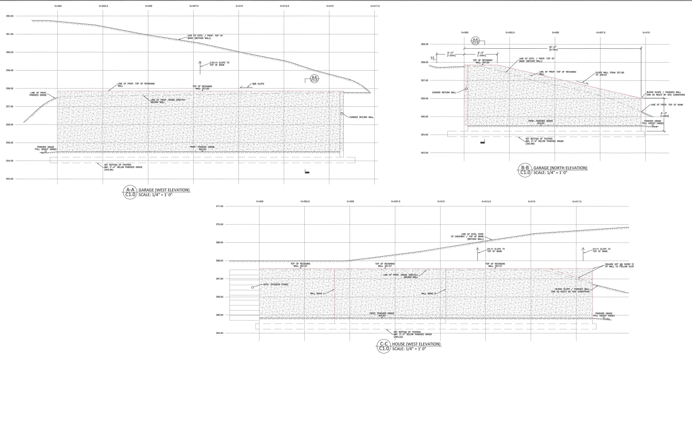
3.4 metres
3.4 metres
2.8 metres
3.3 metres
2.7 metres

