Regional District of Okanagan-Similkameen

Regional District of Okanagan-Similkameen Election Procedure Bylaw No. 2798, 2018

Consolidated for convenience purposes.
Includes all amendments to the text up to March 15, 2018

Summary of Amendments

Bylaw No. | Adopted | Amendment | Purpose
2798.01 | March 15, 2018 | Replace Section 5; add Section 6, and renumber subsequent sections | Clarify dates of advance voting;  provide for additional advance voting opportunities in order to align with contracted municipalities.
2798.02 | February 3, 2022 | Delete subsection 8.2 | Remove the limitations on mail ballot voting

REGIONAL DISTRICT OF OKANAGAN-SIMILKAMEEN
BYLAW NO. 2798, 2018

____________________________________________________________________________
A bylaw to establish various procedures for the conduct of elections and assent voting in the Regional District of Okanagan-Similkameen.
____________________________________________________________________________
WHEREAS under the Local Government Act, the Board may, by bylaw, determine various procedures and requirements to be applied to the conduct of local government elections and assent voting;
AND WHEREAS the Board wishes to establish voting procedures and requirements under that authority;
NOW THEREFORE, the Board of the Regional District of Okanagan-Similkameen, in open meeting assembled, enacts as follows:

CITATION
This Bylaw may be cited for all purposes as “Regional District of Okanagan-Similkameen Election Procedure Bylaw No. 2798, 2018.”

DEFINITIONS
In this Bylaw, except as provided below, all words, terms, and expressions used in this bylaw shall be interpreted in accordance with the definitions in the Local Government Act.
Automated vote counting system means a system that counts and records votes and processes and stores voting results, which includes:
a. vote tabulating units, each of which rests on a ballot box; and
b. portable ballot boxes.
Assent Voting means voting conducted for the Regional District on a bylaw of other matter for which assent of the electors is required; voting on a bylaw or other matter for which the Regional District is authorized by provincial legislation to obtain the assent of the electors; or voting on a referendum pursuant to provincial legislation.
Elector means a resident elector or non-resident property elector of an electoral area of the Regional District of Okanagan-Similkameen as defined in the Local Government Act

Voting Day means the general voting day for an election, a day on which an advance voting opportunity for the election is offered or a day on which a special voting opportunity for the election is offered.

Regional District means the Regional District of Okanagan-Similkameen.

VOTING DAY REGISTRATION ONLY

As authorized in the Local Government Act, registration of electors for all elections and assent voting is hereby limited to registration at the time of voting, including registration at the required advance voting opportunities, additional general voting opportunities and special voting opportunities.

Registration as an elector under 3.1 is effective only for the election or assent voting for which the voting is being conducted at that time.

additional general voting opportunities

4.1 In accordance with Section 106 of the Local Government Act, the Chief Election Officer is authorized to establish additional general voting opportunities for general voting day for each election or assent voting, as required, and to designate the voting places and set the voting hours, within the limits set out in the Local Government Act for such voting opportunities.

4.2 Curbside voting may be available at the voting place for those electors unable to enter the polling place at the time of voting.

Required ADVANCE VOTING OPPORTUNITIES

At least two advance voting opportunities shall be held for an election by voting,

one on the 10th day before general voting day, and

the other on the 7th day before general voting day.

As an exception to section 5.1 of this bylaw, and in accordance with Section 107(2) of the Local Government Act, the additional voting opportunity under 5.1.b. shall not be held for those Electoral Areas within the Regional District with a population of less than 5,000.

Additional ADVANCE VOTING OPPORTUNITIES

Notwithstanding section 5.2 of this bylaw, and in accordance with Section 108 of the Local Government Act, the Chief Election Officer is authorized to establish dates for additional voting opportunities in advance of general voting day, and designate the voting places and set the voting hours for these voting opportunities to allow for aligning voting opportunities with those of contracted municipalities.

USE OF VOTING MACHINES

Elections and Assent Voting in the Regional District of Okanagan-Similkameen may be conducted using an automated vote counting system.

An election official at each voting opportunity shall, as soon as a person enters the voting place to vote and before a ballot is issued to the person, offer and, if requested, direct an election official to provide a demonstration of how to vote using an automated vote counting system.

Upon completion of the voting demonstration, if any, the elector shall proceed as instructed to an election official responsible for registering electors and issuing ballots.

Once the requirements of section 125(1) and (2), as applicable, are met in respect of an elector, the responsible election official shall provide to the elector the ballot or ballots to which the elector is entitled and a secrecy sleeve if requested by the elector.

Upon receiving a ballot, and secrecy sleeve if requested, the elector shall immediately proceed to a voting compartment to mark the ballot.

In order for a mark to be accepted and counted as a valid vote for the election or assent voting, an elector may vote only by making an acceptable mark on the ballot:

Beside the name of the candidate of choice, in the case of an election; or

Beside either ‘yes’ or ‘no’ in the case of an assent voting question;

Once the elector has finished marking the ballot, the elector shall place the ballot into the secrecy sleeve, if applicable, proceed to the vote tabulating unit and, under the supervision of an election official, insert the ballot, directly from the secrecy sleeve if applicable, into the vote tabulating unit

If, before inserting the ballot into the vote tabulating unit, an elector unintentionally spoils a ballot or if the ballot is returned by the vote tabulating unit, the elector may obtain a replacement ballot by advising the election official in attendance and giving the returned or spoiled ballot to the election official.

Upon being advised of the replacement ballot request, the election official shall issue a replacement ballot to the elector and mark the returned or spoiled ballot “spoiled” and shall retain all such ballots separately from all other ballots for return to the chief election officer.

In the case of a returned ballot, if the elector declines the opportunity to obtain a replacement ballot and has not damaged the ballot to the extent that it cannot be reinserted into the vote tabulating unit, the election official shall, using the ballot return override procedure, reinsert the returned ballot into the vote tabulating unit to count any acceptable marks.

Any ballot counted by the vote tabulating unit is valid and any acceptable marks contained on such ballots will be counted in the election or assent voting subject to any determination made under a judicial recount.

Once a ballot has been inserted into the vote tabulating unit and the unit indicates that the ballot has been accepted, the elector shall immediately leave the voting place.

During any period that a vote tabulating unit is not functioning, the election official supervising the unit shall insert all ballots delivered by electors during this time into a portable ballot box. If the vote tabulating unit:

Becomes operational, or

Is replaced with another vote tabulating unit,

The ballots in the portable ballot box shall, as soon as reasonably possible and under the supervision of the presiding election official, be removed by an election official and inserted into the vote tabulating unit to be counted.

Any ballots that are temporarily stored in a portable ballot box that are returned by the vote tabulating unit when being counted shall, through the use of the ballot return override procedure and under the supervision of the presiding election official, be reinserted into the vote tabulating unit to ensure that any acceptable marks are counted.

A sample ballot that may be used in an automated vote counting system is attached as Schedule “A” to this Bylaw.

At the close of voting at an advance voting opportunity, the presiding election official shall:

a. ensure that any remaining ballots in a portable ballot box are inserted into the vote tabulating unit;

b. secure the vote tabulating unit so that no more ballots can be inserted;

c. ensure the register tapes in the vote tabulating unit are not generated;

d. ensure the memory card of the vote tabulating unit is secured; and

e. deliver the vote tabulating unit together with the memory card and all other materials used in the election or assent voting to the chief election officer.

AUTOMATED VOTING PROCEDURES AFTER CLOSE OF VOTING ON GENERAL VOTING DAY

7.17 After the close of voting on general voting day at voting opportunities where a vote tabulating unit was used in the election or assent voting, each presiding election official shall:

ensure that any remaining ballots in a portable ballot box are inserted into the vote tabulating unit;

secure the vote tabulating unit so that no more ballots can be inserted;

generate three copies of the register tape from the vote tabulating unit;

account for the unused, spoiled and voted ballots and place them, packaged and sealed separately, into the election or assent voting materials transfer box along with one copy of the register tape;

complete the ballot account and place the duplicate copy in the election or assent voting materials transfer box;

seal the election or assent voting materials transfer box;

place the voting books, the original copy of the ballot account, one copy of the register tape, completed registration cards (if applicable), keys and all completed administrative forms into the chief election officer portfolio; and

transport all equipment and materials to election headquarters.

At the close of voting on general voting day the chief election officer shall direct the presiding election official for each advance voting opportunity where vote tabulating units were used to proceed in accordance with section 6.17.

At the close of voting on general voting day all portable ballot boxes used in the election or assent voting will be opened under the direction of the chief election officer and all ballots shall be removed and inserted into a vote tabulating unit to be counted, after which the provisions of section 6.17, so far as applicable, shall apply.

Determination of Official Election Results

If a recount is required during the course of determining the official election results, it shall be conducted under the direction of the chief election officer using the automated vote counting system and generally in accordance with the following procedure:

a. the memory cards of all or the applicable vote tabulating units will be cleared;

b. vote tabulating units will be designated for each voting place;

c. all ballots to be recounted will be removed from the sealed ballot boxes; and

d. all ballots to be recounted, except spoiled ballots, will be reinserted in the appropriate vote tabulating units under the supervision of the chief election officer.

MAIL BALLOT VOTING

Mail ballot voting shall be permitted in accordance with the provisions of the Local Government Act, and elector registration shall be permitted to be conducted in conjunction with the vote.

[Deleted]

8.3 Sufficient record will be kept by the Chief Election Officer so that challenges of the elector’s right to vote may be made in accordance with the intent of Section 126 of the Local Government Act.

8.4 A person exercising the right to vote by mail under the provisions of the Local Government Act may be challenged in accordance with, and on the grounds specified in Section 126 of the Local Government Act, until 4:00 pm two days before general voting day.

9. ORDER OF NAME ON BALLOTS

9.1 The order of names of candidates on the ballot will be determined by lot in accordance with Section 117 [Order of names on ballot determined by lot] of the Local Government Act.

10. Nomination Documents

10.1 Nomination documents shall be available for public inspection during regular office hours from the time of delivery at the Regional District office until 30 days after the declaration of the election results.

11. Access to Disclosure Statements

11.1 As authorized under subsection 59(3) of the Local Elections Campaign Financing Act, a fee of $0.25 per page may be imposed for providing a copy or other record of information referred to in subsection 59(1) of the Local Elections Campaign Financing Act.

12. RESOLUTION OF TIE VOTES AFTER JUDICIAL RECOUNT

12.1 In the event of a tie vote after a judicial recount, the tie vote will be determined by lot in accordance with Section 151 of the Local Government Act.

GENERAL

Any enactment referred to herein is a reference to an enactment of British Columbia and regulations thereto, as amended, revised, consolidated or replaced from time to time.

If any part, section, sentence, clause, phrase or word of this Bylaw is for any reason held to be invalid by the decision of any court of competent jurisdiction, the invalid portion shall be severed and the decision that it is invalid shall not affect the validity of the remainder which shall continue in full force and effect and be construed as if the Bylaw had been adopted without the invalid portion.

REPEAL

Bylaw No. 2661, 2014 and any amendments thereto are hereby repealed.

READ A FIRST, SECOND AND THIRD TIME this 18th day of January, 2018.
ADOPTED by at least 2/3 of the votes this 18th day of January, 2018.

_________________________ _______________________
RDOS Board Chair Corporate Officer

Schedule “A”

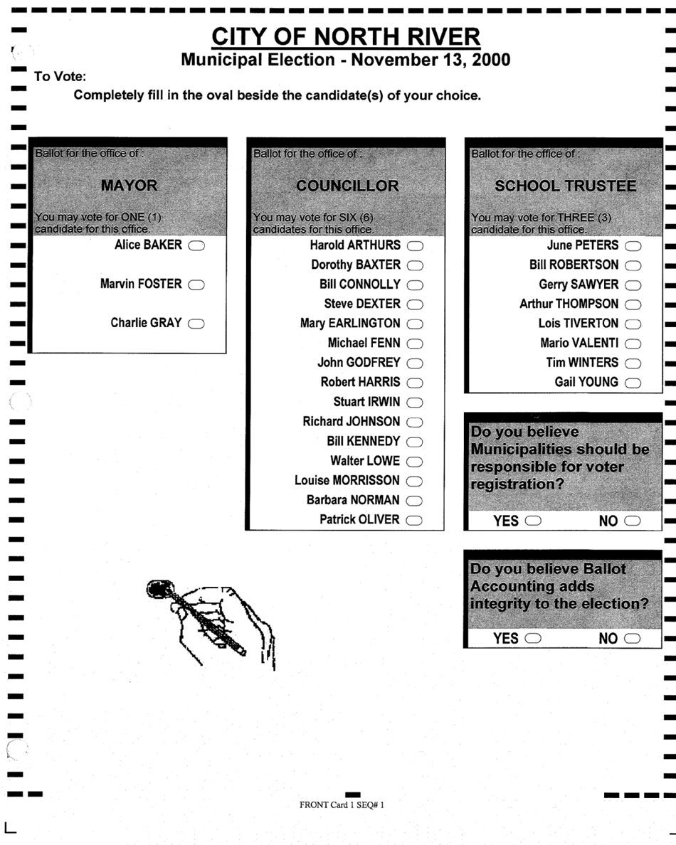

Bylaw No. 2798.01, 2018 adopted March 15, 2018
Bylaw No. 2798.01, 2018 adopted March 15, 2018

