PUBLIC HEARING

2748 River Road, Electoral Area “G”

Zoning & OCP Amendment Bylaws
A zoning & OCP amendments are being sought in order to provide for future development capability at the above noted property.

Amendment Bylaw No. 2975.01, 2025, proposes to amend Schedule ‘B’ (OCP Map) of the Electoral Area “G” Official Community Plan Bylaw No. 2975, 2022, by changing the land use designation of an approximately 58.8 ha portion of property from Agriculture (AG) to Small Holdings (SH).

Amendment Bylaw No. 2781.02, 2025, proposes to amend Schedule ‘2’ (Zoning Map) of the Electoral Area “G” Zoning Bylaw No. 2781, 2017, by applying a land use designation of Small Holdings Three (SH3) to an approximately 58.8 ha portion of the property.
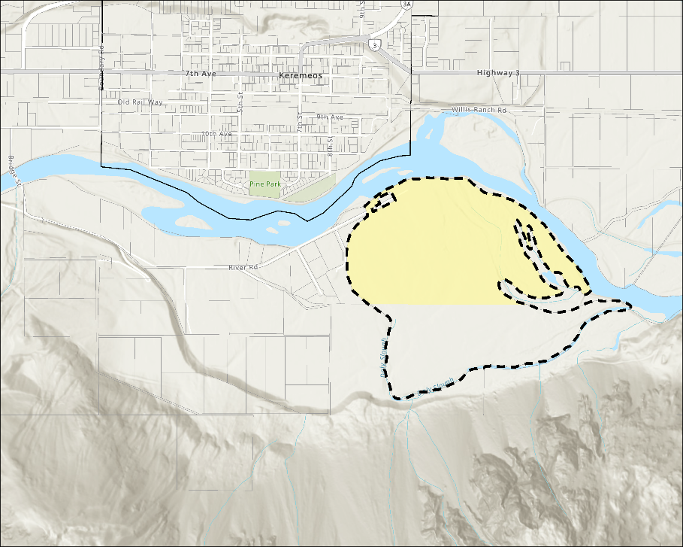
This public hearing will be conducted in a hybrid fashion by video conference using Webex and in-person. If you would like to attend, please refer to the following meeting information:
Amend Zoning Bylaw No. 2781, 2017:
from: N/A
to: Small Holdings Three (SH3)
(YELLOW SHADED AREA ONLY)
Amend OCP Bylaw No. 2975, 2022:
from: Agriculture (AG)
to: Small Holdings (SH)
(YELLOW SHADED AREA ONLY)
Date: | November 20, 2025
Time: | 9:00 am
Location: | 101 Martin St, Penticton, BC
Computer: | https://rdos.webex. com
Phone: | 1-833-311-4101
Meeting #: | 2772 761 7646
Password: | RD@S (7317 by phone)
Copies of the bylaw(s), along with other basic information, may be inspected at: www.rdos.bc.ca (Property & Development → Planning, Zoning & Subdivision → Current Applications → Electoral Area “G” → G2025.011-ZONE).
This bylaw may also be inspected at the Regional District of Okanagan-Similkameen office at 101 Martin Street, Penticton, BC, on weekdays (excluding statutory holidays) between the hours of 8:30 a.m. to 4:30 p.m. up until the close of the public hearing on Thursday, November 20, 2025.
Anyone who considers themselves affected by Amendment Bylaw Nos. 2975.01 & 2781.02, 2025, can present written information to the Regional District prior to or at the public hearing and may also speak at the public hearing. No letter, report or representation from the public will be received after the conclusion of the public hearing.

