**Development   
Variance Permit**

## FILE NO.: E2022.053-DVP

|  |  |  |  |  |  |
| --- | --- | --- | --- | --- | --- |
| |  |  |  |  |  | | --- | --- | --- | --- | --- | | Owner: |  |  | Agent: |  | |

**GENERAL CONDITIONS**

1. This Development Variance Permit is issued subject to compliance with all of the bylaws of the Regional District of Okanagan-Similkameen applicable thereto, except as specifically varied or supplemented by this Permit.
2. The land described shall be developed strictly in accordance with the terms and conditions and provisions of this Permit, and any plans and specifications attached to this Permit that shall form a part thereof.
3. Where there is a conflict between the text of the permit and permit drawings or figures, the drawings or figures shall govern the matter.
4. This Development Variance Permit is not a Building Permit.

### **APPLICABILITY**

1. This Development Variance Permit is substantially in accordance with Schedules ‘A’, ‘B’, ‘C’, ‘D’, and applies to and only to those lands within the Regional District described below, and any and all buildings, structures and other development thereon:

|  |  |
| --- | --- |
| Legal Description: | Lot 5, Plan KAP576, District Lot 207, SDYD, Except Plan H16696 |
| Civic Address: | 2965 Gammon Road |
| Parcel Identifier (PID): | 012-219-134 Folio: C-02078.000 |
|  |  |

### **CONDITIONS OF DEVELOPMENT**

1. The land specified in Section 5 may be developed in accordance with the following variances to the Okanagan Valley Zoning Bylaw No. 2800, 2022, in the Regional District of Okanagan-Similkameen:
2. the minimum front parcel line setback for an accessory building in the Agriculture One (AG1) Zone, as prescribed in Section 13.1.5(a), is varied:

i) from: 7.5 metres

to: 4.03 metres to the outermost projection as shown on Schedule ‘B’.

**COVENANT REQUIREMENTS**

1. Not Applicable

**SECURITY REQUIREMENTS**

1. Not applicable

**EXPIRY OF PERMIT**

1. The development shall be carried out according to the following schedule:
2. In accordance with Section 504 of the *Local Government Act* and subject to the terms of the permit, if the holder of this permit does not substantially start any construction with respect to which the permit was issued within two (2) years after the date it was issued, the permit lapses.
3. Lapsed permits cannot be renewed; however, an application for a new development permit can be submitted.

Authorising resolution passed by the Regional Board on ________________, 2022.

___________________________________

B. Newell, Chief Administrative Officer

****Regional District of Okanagan-Similkameen

101 Martin St, Penticton, BC, V2A-5J9

Tel: 250-492-0237 Email: [planning@rdos.bc.ca](mailto:planning@rdos.bc.ca)

Development Variance Permit File No. E2022.053-DVP

Schedule ‘A’

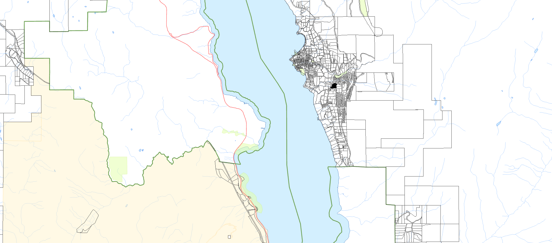



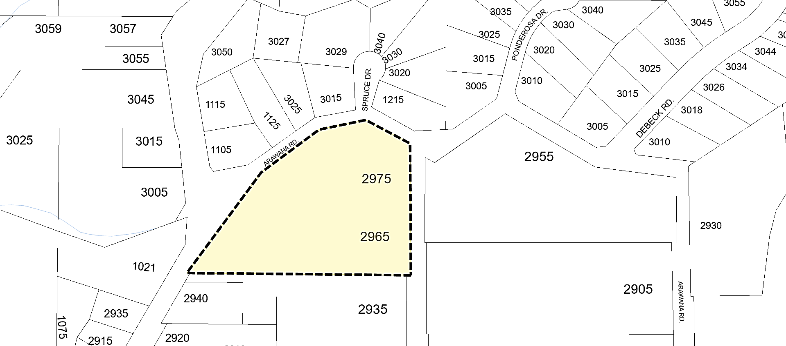

**NARAMATA**

Subject

Parcel

****Regional District of Okanagan-Similkameen

101 Martin St, Penticton, BC, V2A-5J9

Telephone: 250-492-0237 Email: [info@rdos.bc.ca](mailto:info@rdos.bc.ca)

Development Variace Permit File No. E2022.053-DVP

Schedule ‘B’

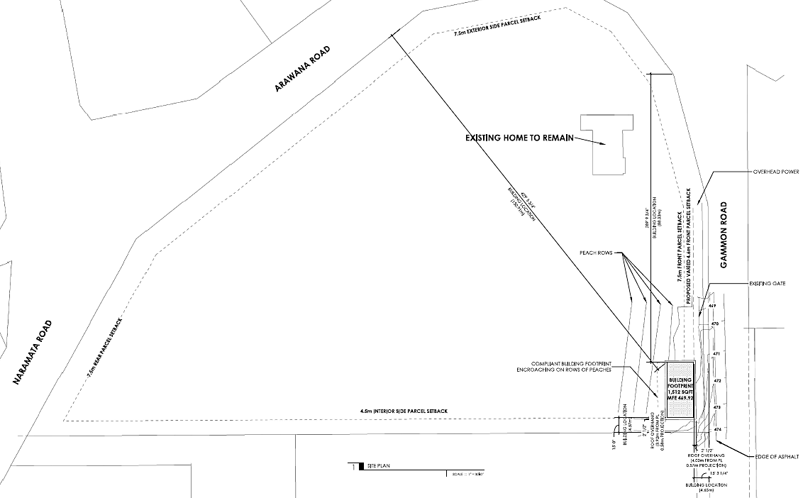

**4.03 metres**

****Regional District of Okanagan-Similkameen

101 Martin St, Penticton, BC, V2A-5J9

Telephone: 250-492-0237 Email: [info@rdos.bc.ca](mailto:info@rdos.bc.ca)

Development Variace Permit File No. E2022.053-DVP

Schedule ‘C’

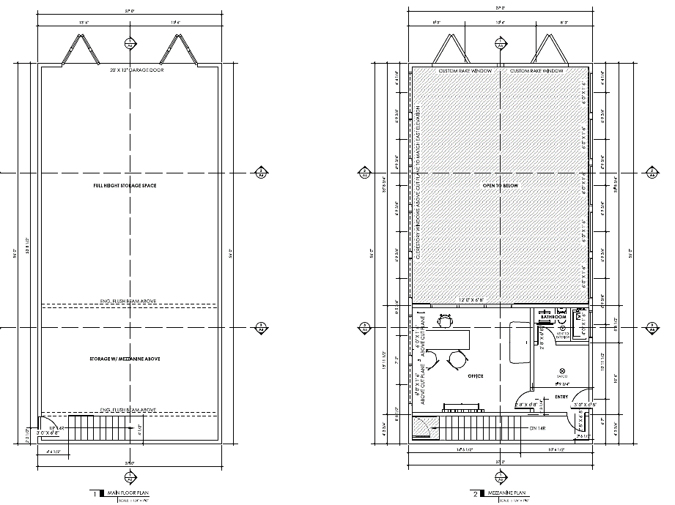

****Regional District of Okanagan-Similkameen

101 Martin St, Penticton, BC, V2A-5J9

Telephone: 250-492-0237 Email: [info@rdos.bc.ca](mailto:info@rdos.bc.ca)

Development Variace Permit File No. E2022.053-DVP

Schedule ‘D’

