**_________________**

# BYLAW NO. 2455.47

**_________________**

**REGIONAL DISTRICT OF OKANAGAN-SIMILKAMEEN**

**BYLAW NO. 2455.47, 2021**

**A Bylaw to amend the Electoral Area “D” Zoning Bylaw No. 2455, 2008**

The REGIONAL BOARD of the Regional District of Okanagan-Similkameen in open meeting assembled, ENACTS as follows:

1. This Bylaw may be cited for all purposes as the “Electoral Area “D” Zoning Amendment Bylaw No. 2455.47, 2021.”
2. The “Electoral Area “D” Zoning Bylaw No. 2455, 2008” is amended by:
3. adding a new sub-section 19.20.2 (Site Specific Tourist Commercial (CT1s) Provisions) under Section 19.20 (Site Specific Designations) to read as follows:

.2 in the case of an approximately 0.6 ha area of theland described as Lot 1, Plan KAP35151, Sublot 38, District Lot 2710, SDYD (4899 Eastside Road), and shown shaded yellow on Figure 19.20.2:

1. despite Section 15.1.5, the maximum number of accessory dwelling units shall be one (1) 180 m2 accessory dwelling unit and one (1) 150 m2 accessory dwelling unit.

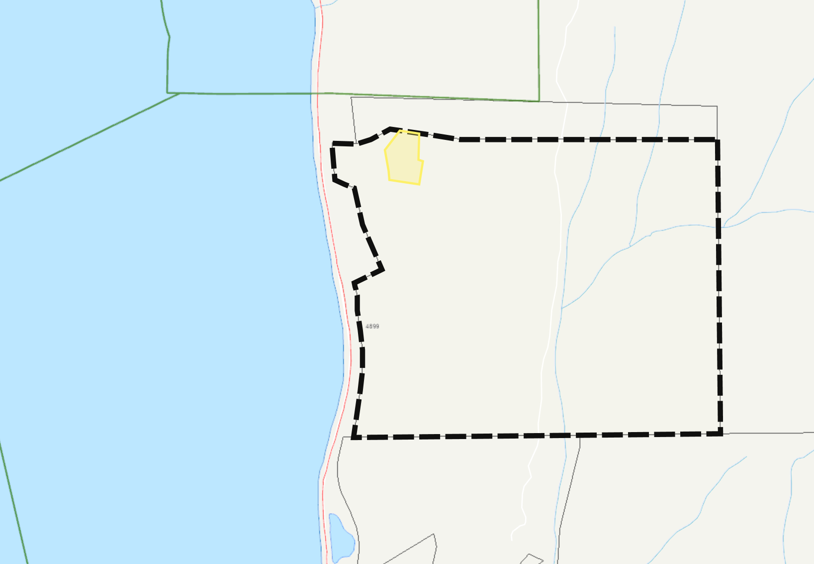

**Figure 19.20.2**

SKAHA LAKE

**EASTSIDE ROAD**

Tourist Commercial Site Specific (CT1s)

(YELLOW SHADED AREA)

1. The Official Zoning Map, being Schedule ‘2’ of the Electoral Area “D” Zoning Bylaw No. 2455, 2008, is amended by changing the land use designation on**:**
2. an approximately 0.6 ha area of the land described as Lot 1, Plan KAP35151, Sublot 38, District Lot 2710, SDYD, and shown shaded orange on Schedule ‘B’, which forms part of this Bylaw, from Tourist Commercial One (CT1) to Tourist Commercial Site Specific (CT1s) Zone.
3. an approximately 29.2 ha area of the land described as Lot 1, Plan KAP35151, Sublot 38, District Lot 2710, SDYD, and shown shaded yellow on Schedule ‘B’, which forms part of this Bylaw, from Resource Area (RA) to Conservation Area (CA).
4. an approximately 15.7 ha area of the land described as Lot 1, Plan KAP35151, Sublot 38, District Lot 2710, SDYD, and shown shaded purple on Schedule ‘B’, which forms part of this Bylaw, from Resource Area (RA) to Large Holdings Two (LH2).
5. iii) an approximately 1.04 ha area of the land described as Lot 1, Plan KAP35151, Sublot 38, District Lot 2710, SDYD, and shown shaded green on Schedule ‘B’, which forms part of this Bylaw, from Tourist Commercial One (CT1) to Large Holdings Two (LH2).

READ A FIRST AND SECOND TIME this 21st day of October, 2021.

PUBLIC HEARING held on this 18th day of November, 2021.

READ A THIRD TIME this _____ day of ___________, 2021.

ADOPTED this _____ day of ___________, 2021.

_______________________ _________________________

Board Chair Corporate Officer

****Regional District of Okanagan-Similkameen

101 Martin St, Penticton, BC, V2A-5J9

Tel: 250-492-0237 Email: [info@rdos.bc.ca](mailto:info@rdos.bc.ca)

Amendment Bylaw No. 2455.47, 2021 File No. D2021.016-ZONE

Schedule ‘A’

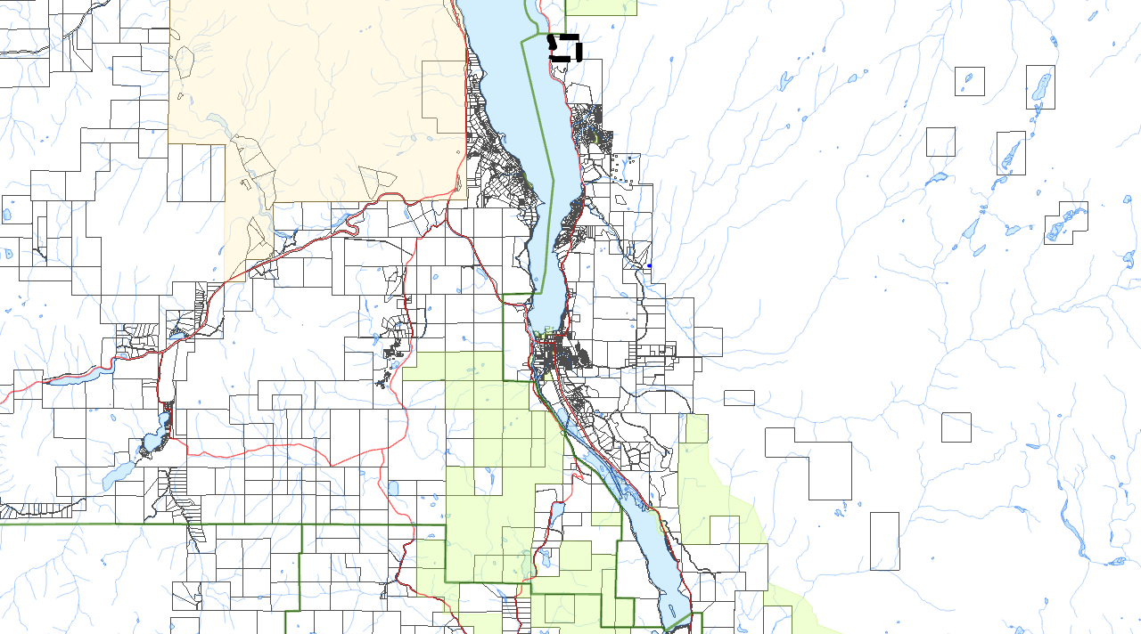



**KALEDEN**

Subject Parcel

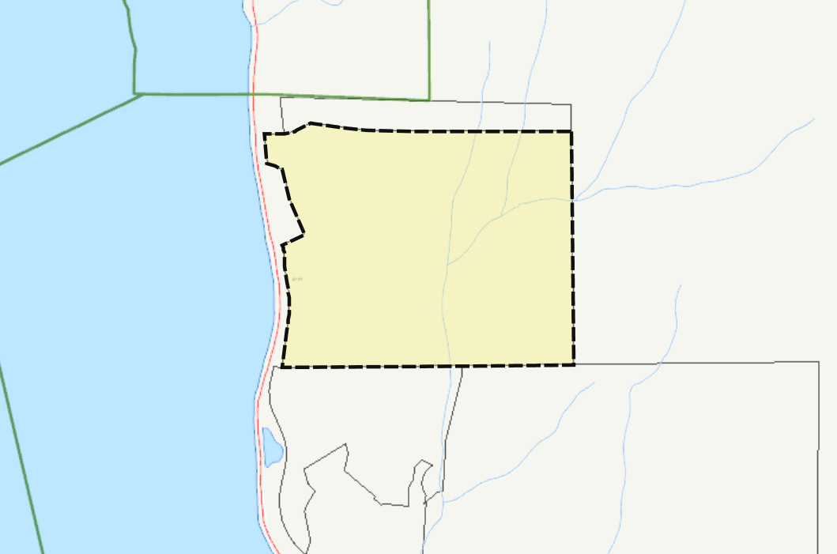

****Regional District of Okanagan-Similkameen

101 Martin St, Penticton, BC, V2A-5J9

Tel: 250-492-0237 Email: [info@rdos.bc.ca](mailto:info@rdos.bc.ca)

Amendment Bylaw No. 2455.47, 2021 File No. D2021.016-ZONE

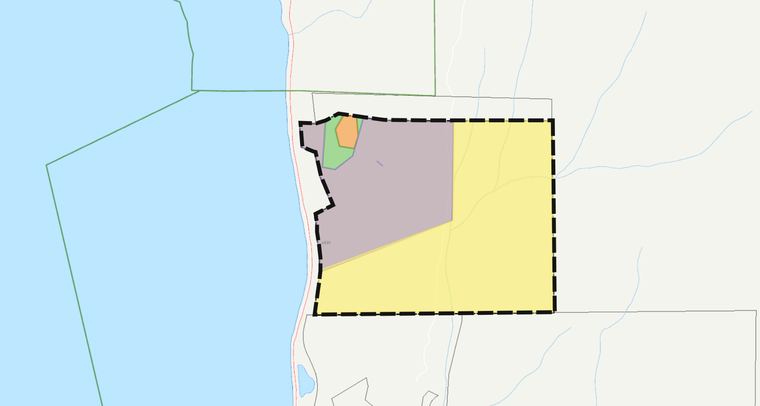Schedule ‘B’

**Amend Zoning Bylaw No. 2455, 2008**

from: Tourist Commercial (CT1)

to: Tourist Commercial Site Specific (CT1s)

(ORANGE SHADED AREA)

**Amend Zoning Bylaw No. 2455, 2008**

from: Tourist Commercial (CT1)

to: Large Holdings Two (LH2)

(GREENSHADED AREA)

**Amend Zoning Bylaw No. 2455, 2008**

from: Resource Area (RA)

to: Large Holdings Two (LH2)

(PURPLESHADED AREA)

**Amend Zoning Bylaw No. 2455, 2008**

from: Resource Area (RA)

to: Conservation Area (CA)

(YELLOW SHADED AREA)